Release Notes

Basic Information
Product Model | NTA NX3-2000E/1000E/HD2100/HD2200  NTA VM
Software Version | V4.5R90F02SP06
Upgrade File | update_nta_V4.5R90F02SP06.210531build43608.bin  c6a0b4bfad17e439162963cc43c90c5b
Release Date | 2021-05-31
How to Obtain | Obtain the upgrade file from the upgrade system or contact NSFOCUS technical support.

Version Mapping
Hardware Model | NTA NX3-2000E/1000E (NSF-2800)  NTA NX3-HD2100/HD2200 (C236)
ADS | V4.5R90F02SP07
ADSM | v4.5R90F02.SP09
NTA-ATM | V4.5R89F03
MagicFlow | V4.5R90F01SP01 and above
Threat Analysis and Traceback System (TAT) | TAT: V2.0.0
Client Browser | Chrome  Firefox
Documentation | None

New Requirements
No. | Requirement Description
1 | A local authentication mechanism needs to be added for vNTA.
2 | License options need to be adjusted.
3 | Link backup is required.
4 | An API needs to be added to obtain the authentication status.
5 | Emails needs to be sent via STARTTLS.
6 | web APIs need to be added for manual FlowSpec diversion.
7 | Flow statistics is required for router interfaces.
8 | Logs need to be sent to the cloud cleaning platform via syslog.

New Functions

Addition of a Local Authentication Mechanism on vNTA
Description
Subject to customer network restrictions and deployment constraints, vNTA cannot be connected to the Internet for cloud authentication, and thus requires a local authentication mechanism. For this purpose, a local authentication mechanism is added for vNTA to collaborate with ADS M for license authentication.
Configuration and Use
After login to the system, set Authorization Mode to Local, specify the IP address of ADS M, and upload a license for authentication by ADS M.
              - Selecting local authorization
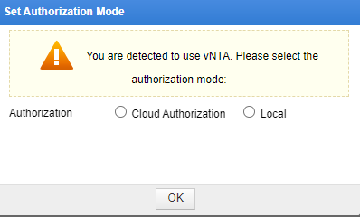

              - Configuring local authorization
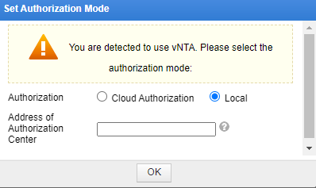

4.2 License Option Adjustment
Description
With addition of new models and performance improvement, NTA/vNTA needs to be divided into different grades. For device grading, the license is provided in terms of the maximum number of flows that can be processed by NTA per second. After adjustment, flows per second are limited to 60,000/100,000 for NTA-HD2100, 120,000/180,000/240,000 for NTA-HD2200, and 60,000/120,000/180,000/240,000/300,000 for vNTA. All models of device will be restarted if their licenses are updated. For the same model of V4.5R90F02SP05 and earlier, the license update does not require device restart.

4.3 Addition of Link Backup
Description
The access network is a VRRP environment composed of two switches, each of which needs to have a link directly connected to NTA to implement link backup.

              - Link backup
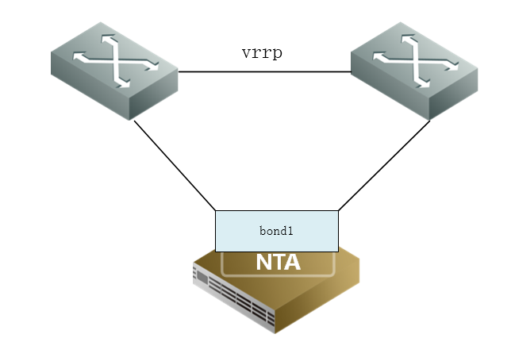

Configuration and Use
Choose Administration > Network > Bond Configuration, and click Add to select two NICs to configure link backup.
              - Configuring link backup
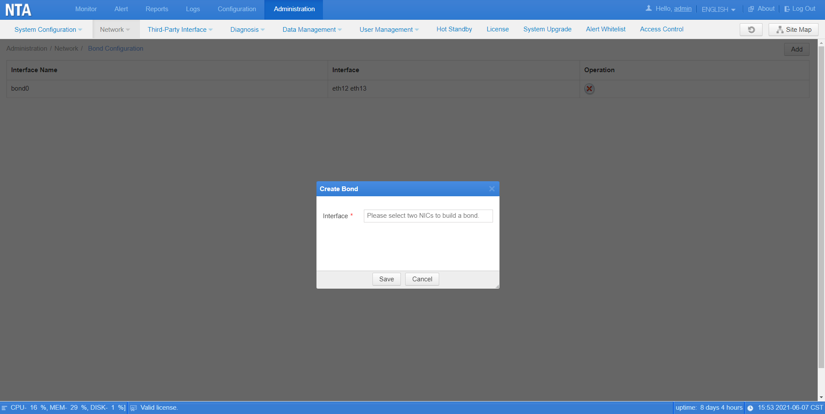

4.4 Addition of an API for Obtaining the Authentication Status
Description
An API should be added in vNTA for a device collaborating with it to proactively call to monitor the current license authentication status, thus preventing business interruption caused by failed license authentication (cloud authentication and local authentication). This API is called within ADS M and ADBOS.

4.5 Addition of the Function of Sending Emails via STARTTLS
Description
The SMTP server requires an Office 365 mail to be sent via STARTTLS, so STARTTLS is used for email encryption.
Configuration and Use
Choose Administration > Third-Party Interface > Email Service > SMTP Server, and select STARTTLS as the authentication method.
              - Configuring STARTTLS in email service
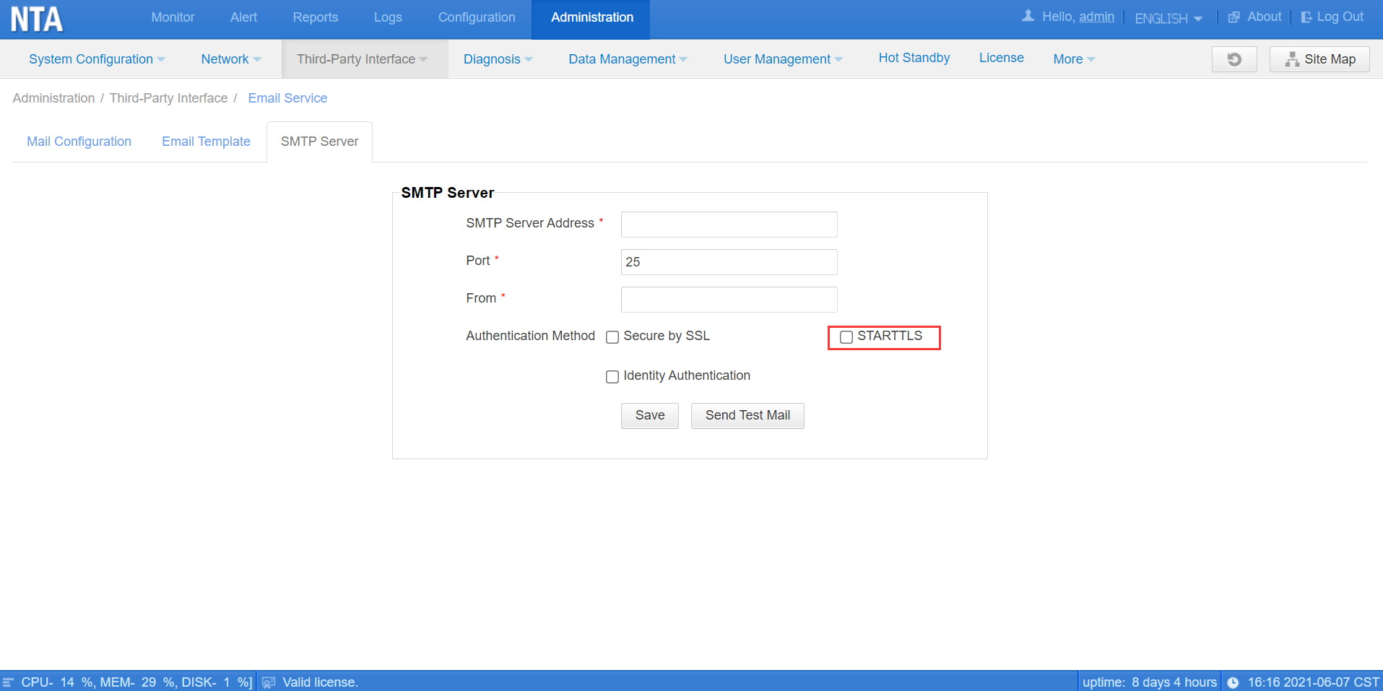

4.6 Addition of Web APIs for Manual FlowSpec Diversion
Description
Some customers hope to manage NTA's FlowSpec diversion via APIs, so Web APIs are added to create, modify, delete, dispatch, withdraw, and obtain policies for manual FlowSpec diversion. For how to use web APIs, see Web API Description.

4.7 Addition of Flow Statistics for Interfaces of Interest on Routers
Description
For routers under monitoring, it is often unnecessary to follow up on flows of each interface. Therefore, disable flow statistics of unnecessary interfaces for better performance of NTA.
Configuration and Use
Choose Configuration > Objects > Routers, and click Interface Number to determine whether to enable router interface flow statistics in the Flow Operation column.
              - Configuring router interface flow statistics
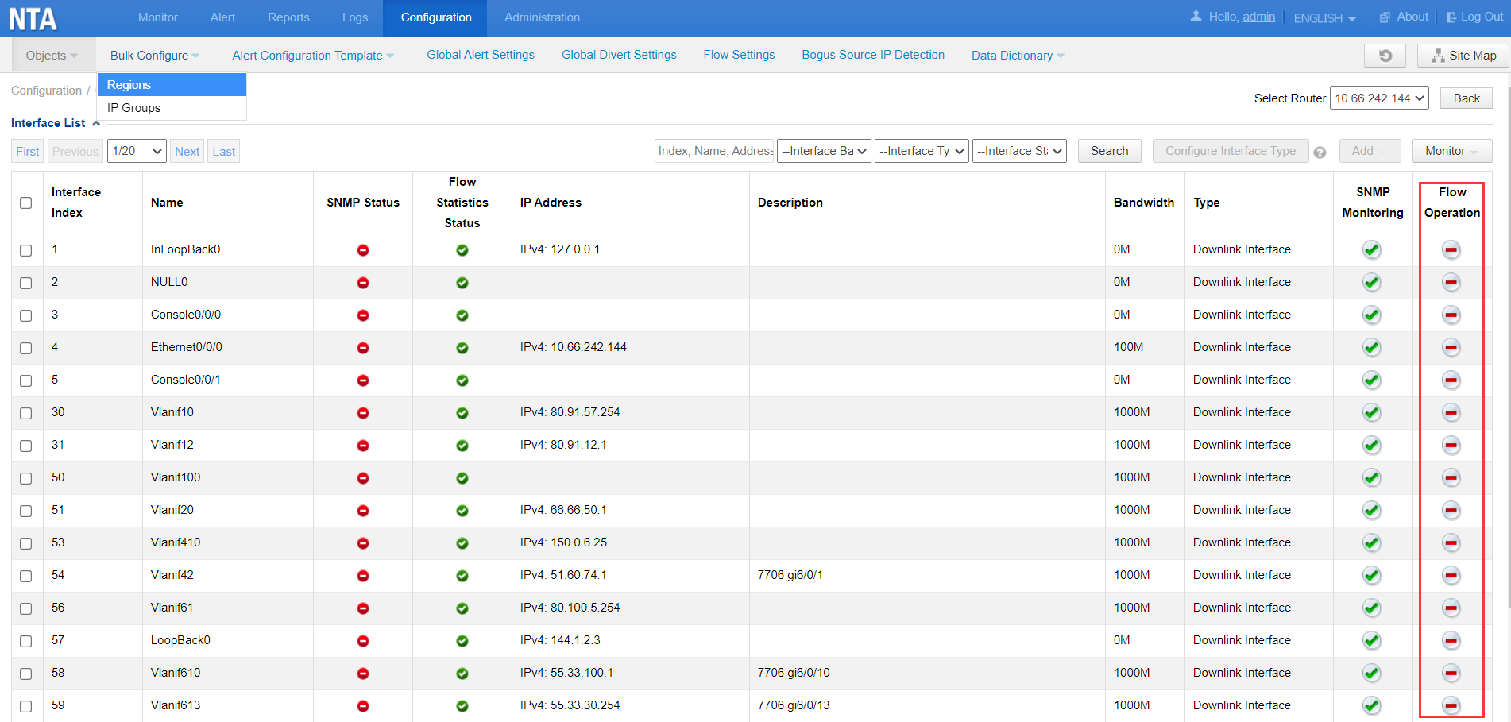

4.8 Addition of the Function of Sending Syslog Logs to the Cloud Cleaning Platform
Description
Currently, NTA collects alerts every 30 seconds and sends them to the cloud cleaning platform. However, there is a bit of delay for the cloud cleaning platform to receive such alerts, making rapid attack discovery and cleaning impossible. Therefore, NTA collects alerts every second and sends them to the cloud cleaning platform via UDP-based syslog.
Configuration and Use
Choose Administration > Third-Party Interface > Cloud Cleaning Platform, and click Add to configure the IP address and port of the cloud cleaning center and select Enable for Send Syslog.
              - Configuring syslog log sending to the cloud cleaning platform
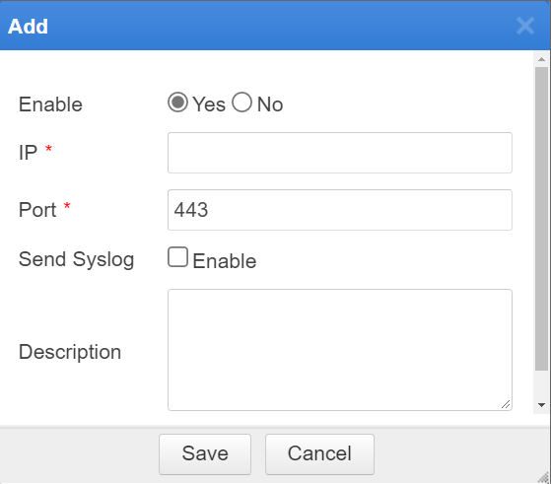

5 Fixed Bugs
- 197524 Although flow statistics is enabled only for input interfaces, flow statistics are also collected for output interfaces in the same PDU.
- 197444 If PPPoE is enabled in console mode, the system prompts that it is successfully enabled, but it actually does not take effect.
- 197444 Deletion of the master IPv4 address of an interface causes the slave IP address to be deleted.
- 195414 When a report fails to be exported in PDF format within 1 minute, the system prompts that the verification has expired and asks for re-verification and export.

6 Upgrade Procedure
Note: You must upgrade in strict accordance with the upgrade path.
The upgrade procedure is as follows:
          - Log in to the web-based manager of NTA and choose Administration > System Upgrade.
          - Browse to update_nta_V4.5R90F02SP06.210531build43608.bin and click Upload.
          - Read upgrade notes and click Confirm Upgrade to continue the upgrade.
          - Wait 5 minutes for the installation to complete before refreshing the current page. Click About in the upper-right corner of the web-based manager to check the current system version. If Product Version is V4.5R90F02SP06.210531build43608, the upgrade succeeded. If not, the upgrade failed and you need to contact NSFOCUS technical support.
----End
It is normal that the following situations arise in the upgrade process:
1. The web-based manager displays an error message "502 Bad Gateway" for or directly denies your access request.
2. All services will stop running.
3. The upgrade takes about 5 minutes. If the page remains unresponsive after 5 minutes, you need to manually refresh the page.
Note that the system will automatically restart after the upgrade is complete.

7 Upgrade Path
